Calculus 101

Limit: The value that a function approaches (without necessarily being equal to said value) as x approaches a specific value

- Limits only exist if the same value is approached from both sides of x
- LH limit: approached from the left side (indicated by -)
- RH limit: approached from the right side (indicated by +)

We say that a sequence of ratios has a limiting value of ᴓ

Euler’s Number (e):

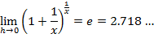

Derivative: The instantaneous rate of change of a function with respect to a variable

- The derivative is also the slope of the tangent line drawn to the curve at a specific point
- Differentiate: find the derivative

Method of First Principles:

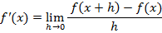

Types of Discontinuity

- Infinite (asymptote)
- Removable (hole)
- Jump (functions defined piecewise)

- All polynomial functions are continuous -- substitution solves limits

∀: “for all”

Indeterminate Form:

- Simplify to get rid of
  - Factor and eliminate common factors in the numerator and denominator
  - Complete the square/cubic (using the conjugate)
- Substitute to find limit

Derivative Rules:
Rule | Function Notation | Leibniz Notation
Constant |  | 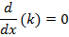
Linear |  | 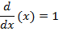
Power |  | 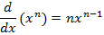
Constant Multiple |  | 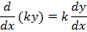
Sum or Difference |  | 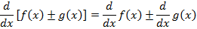
Product |  | 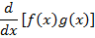  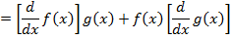
Quotient | 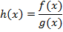  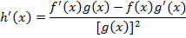 | 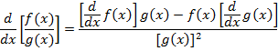
Chain |  | 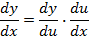
Power of a Function |  | 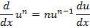
Exponential |  | 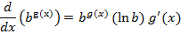
Sine |  | 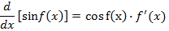
Cosine |  | 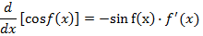
Tangent |  | 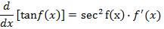
Secant |  | 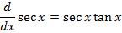
Cosecant |  | 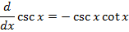
Cotangent |  | 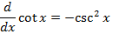
Natural Logarithm | 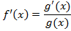 | 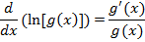
Logarithm | 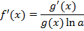 | 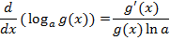

Logarithmic Differentiation:

- Take the natural logarithms of each side and rewrite
- Differentiate both sides with respect to x

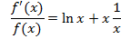

Exponential Functions:

- For exponential functions, 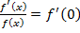
  - 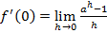
- 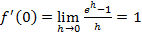
- If and then 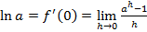

For position [s(t)], velocity [v(t)], and acceleration [a(t)] functions:

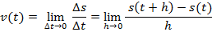

Graphing Functions:

- (points of inflexion)
- Solving indicates whether critical points are maxima or minima
  - If the critical point is a maximum(concave down)
  - If the critical point is a minimum (concave up)

